Project Design Phase-II Technology Stack (Architecture & Stack)

|  |  |
| --- | --- |
| Date | 03 October 2022 |
| Team ID | **PNT2022TMID16166** |
| Project Name | Project – IOT based smart crop protection system |
| Maximum Marks | 4 Marks |

# Technical Architecture:

The Deliverable shall include the architectural diagram as below and the information as per the table1 & table 2

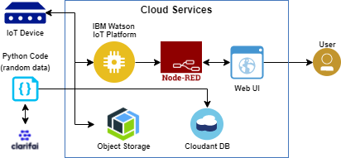

# Table-1 : Components & Technologies:

|  |  |  |  |
| --- | --- | --- | --- |
| **S.No** | **Component** | **Description** | **Technology** |
| 1. | Arduino Uno | The Arduino Uno is an open- source microcontroller board based on the Microchip  ATmega328P microcontroller | Arduino programming done in **C++.** |
| 2. | Application Logic-1 | Logic for PIR sensor data | C++/Python |
| 3. | Application Logic-2 | Logic for Temperature sensor data | C++/Python |
| 4. | Application Logic-3 | Logic for fire sensor data | C++/Python |
| 5. | GSM | The Arduino GSM shield allows an Arduino board to connect to the internet,  send and receive SMS, and make voice calls using the  GSM library. | C++/Python |
| 6. | Cloud Database | Database Service on Cloud | IBM Watson IoT  platform,Cloudant DB |
| 7. | Cloud Server | Application deployment on Local  System /Cloud | IBM Watson IoT  Platform, NodeRed |
| 8. | User Interface | How user interacts with  application toalert the Farmer | HTML, CSS, JavaScript  Python etc. |
| 9. | External API-1 | Purpose of External API used in theapplication to locate the  crops. | Google Maps Geolocation API |

**Table-2: Application Characteristics:**

|  |  |  |  |
| --- | --- | --- | --- |
| **S.No** | **Characteristics** | **Description** | **Technology** |
| 1. | Open-Source  Microcontroller | Arduino Uno is used to make  the IoT device | C++/Python |
| 2. | Security | Encryption/Decryption used  for securitypurpose | GSM, Python |
| 3. | Scalable Architecture | New features can be added. | Node Red |
| 4. | Availability | Web application can be accessed fromanywhere | IBM Watson IoT Platform,HTML,  CSS, Java Script |
| 5. | Performance | All Farmers can access the application atsame time. | Cloudant DB, IBM Watson IoT  Platform |